You’re Invited to “AACtion Camp!”

To minimize health & safety risks for participating families,
NEAT’s 3rd Annual Summer Augmentative and Alternative Communication (AAC) Event

will continue again this year as a virtual, collaborative experience!
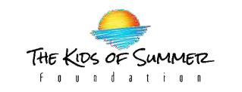
Sponsored by:
and with support from the Neag Foundation, this event is FREE and open to families and professionals looking to have fun with AAC!
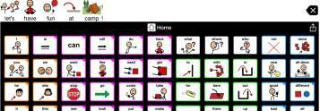

Mark your calendar to “Zoom” with us on
July 19, 20, & 21

At “AACtion Camp” You Will:

- Connect with others
- Participate in family-friendly, camp-themed activities
  - Learn new tips and tricks for AAC implementation

Keep in touch for more information, coming soon!
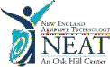
Twitter: @NEATwithElena, @NEATwithMargie | Instagram: NEAT_in_AACtion
Website: https://assistivetechnology.oakhillct.org/
Email: Margaret.Hislop@oakhillct.org

